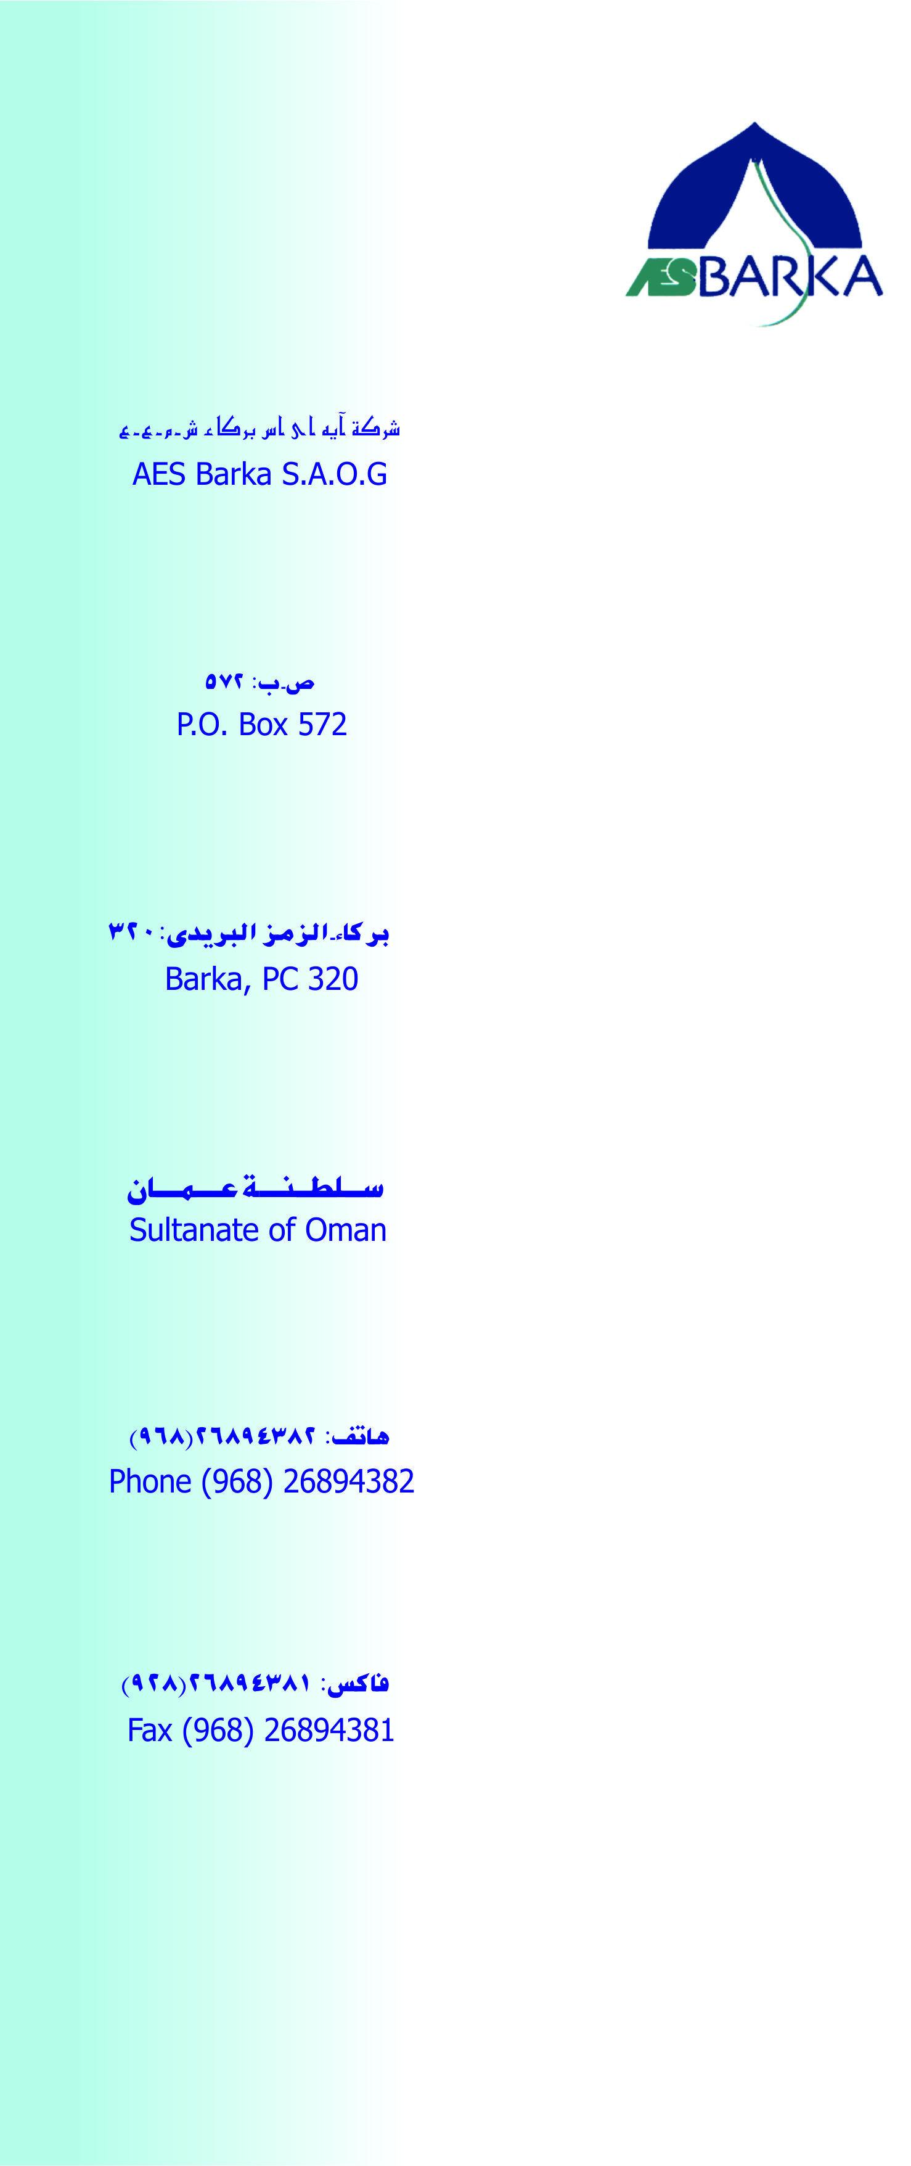

**Dated: <To>**

**TO WHOM SO EVER IT MAY CONCERN**

This is to certify that Mr. <Name> S/O <fname>, holder of Pakistani Passport No: <Passport> has worked with Alnadha Company LLC CO O who are engaged for supply of manpower to AES BARKA SAOG, 450MW and 20MIGD Desalination Plant. He worked under direct supervision of AES engineers as a <Designation> from <From> to   
<To>.

He has worked on this project during construction and maintenance, installation & erection phase. He has worked on safety control coordination on project site. He also worked as a Installation on High voltage transmission line & distribution control rely panels.

During this period we found him sincere, hardworking and co-operative.

He is an asset to any employer who employs him. We wish him all success.

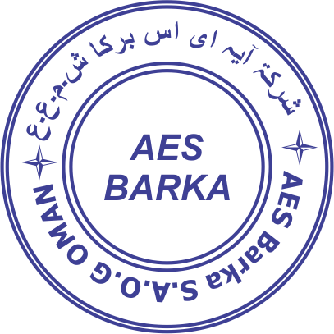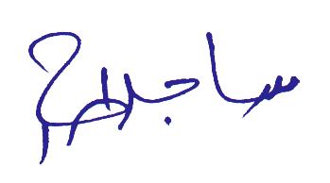

SAJID BIN AHMAD

(Operation & Maintenance Engineer)